off-line version

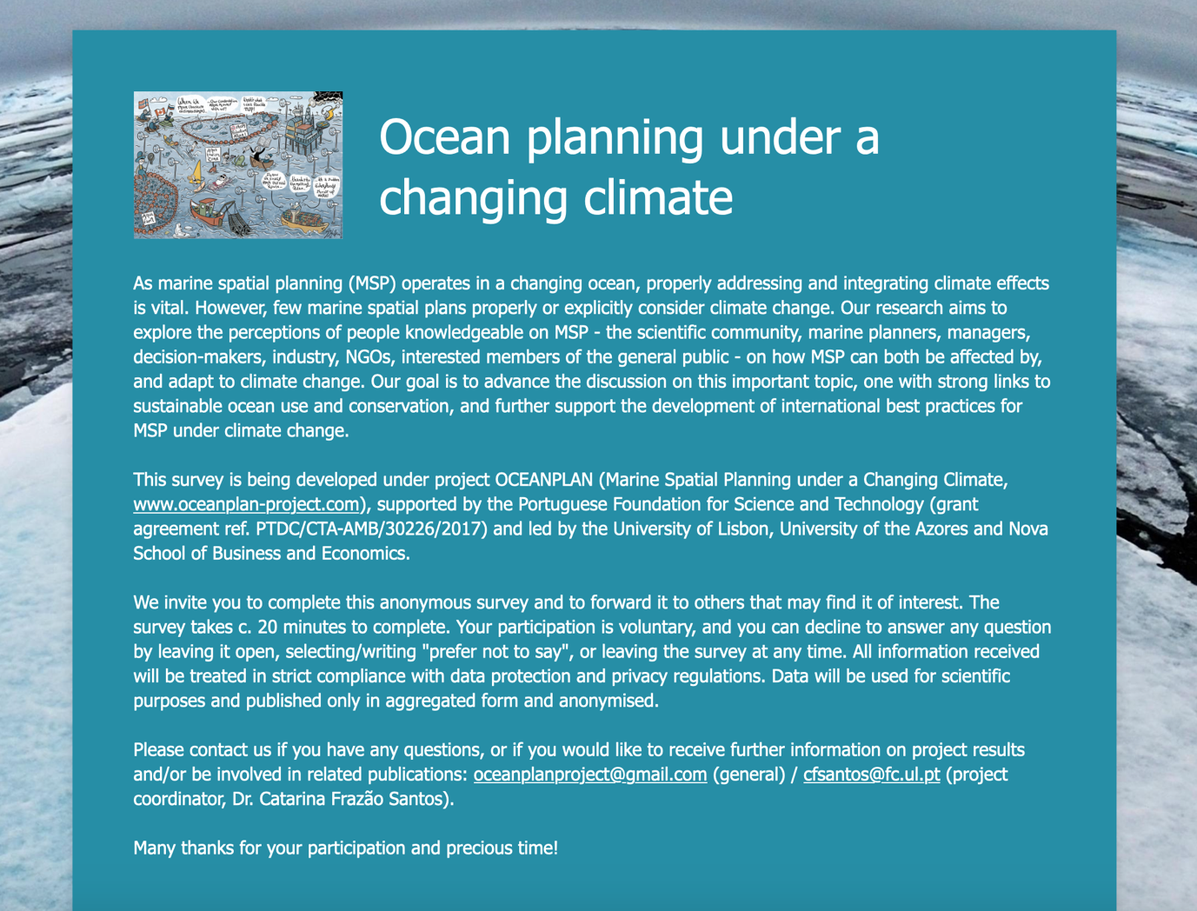
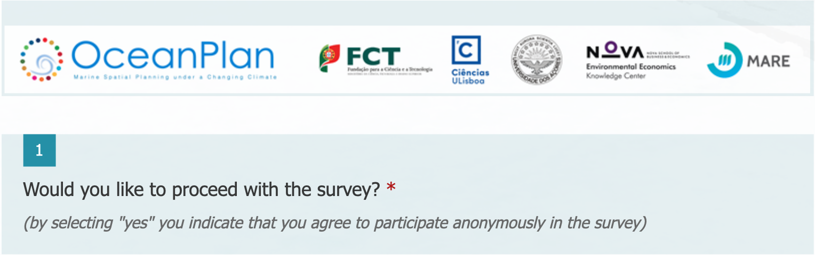

Yes
No

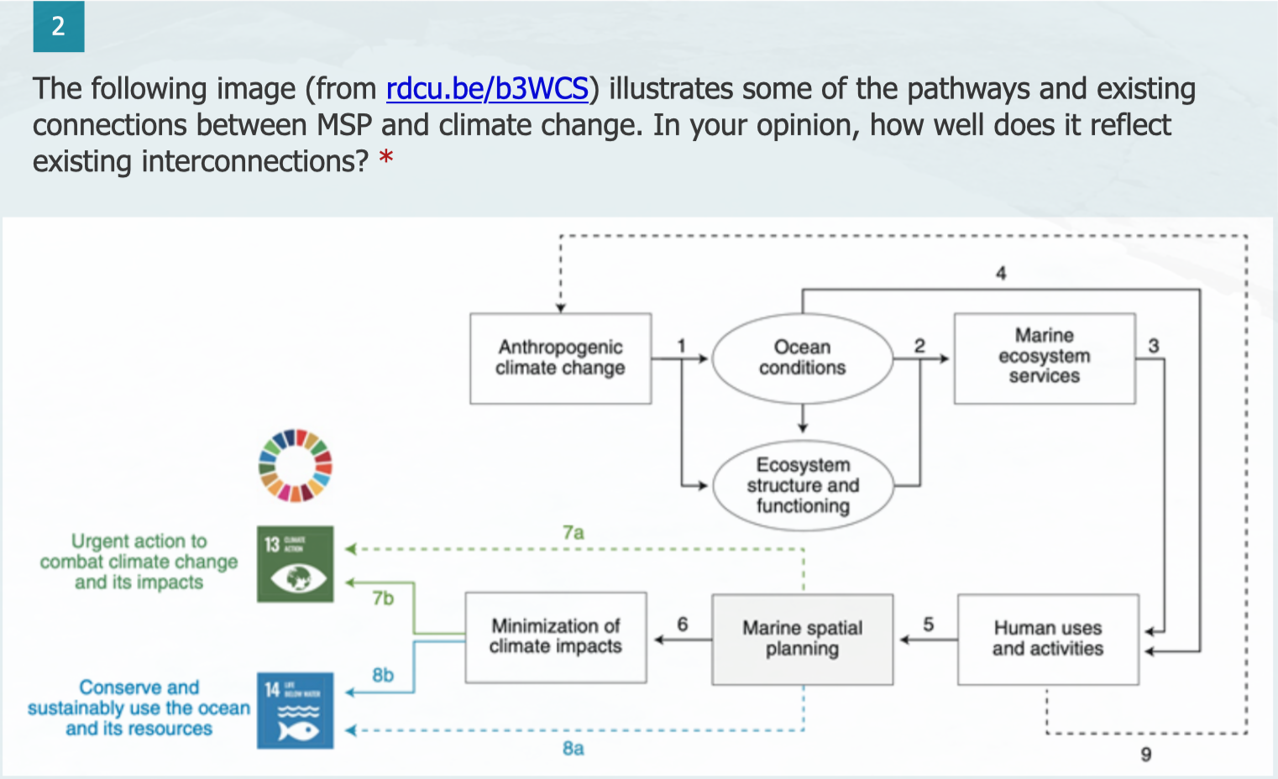

The model identifies extremely well the existing interconnections between MSP and climate change.
The model only identifies some of the existing pathways and connections between MSP and climate change, while other important ones are missing. Go to 3.1
I disagree with some of the links identified in the model. Go to 3.2
I entirely disagree with the model. Go to 3.3

Other: ______________________________________________________

3.1

3.2

3.3

 | 1 | 2 | 3 | 4 | 5
Not at all |  |  |  |  |  | Very much

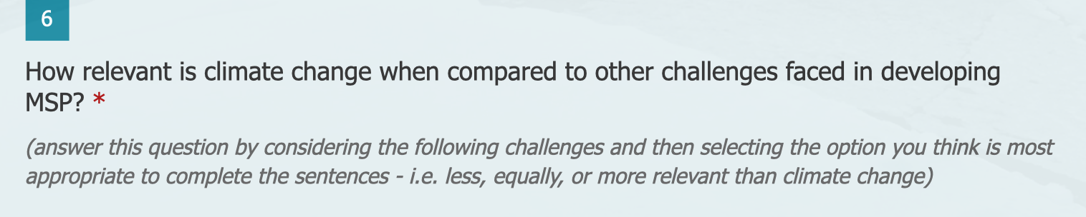

 | More relevant | Equally relevant | Less relevant | Not sure/Do not know
Environmental sustainability (balancing development with nature conservation) is _______ as a challenge to MSP than climate change
Realpolitik factors (institutional/governance constrains and limitations) are _______ as a challenge to MSP than climate change
Social sciences (integrating human dimensions and data) are _______ as a challenge to MSP than climate change
Participation (properly involving stakeholders) is _______ as a challenge to MSP than climate change
Transboundary issues (among countries and with international waters) are _______ as a challenge to MSP than climate change
Monitoring and evaluation (ensuring proper monitoring and evaluation of MSP performance) are _______ as a challenge to MSP than climate change

Yes Go to 8.1
Not sure Go to 8.2
No Go to 9

8.1

8.2

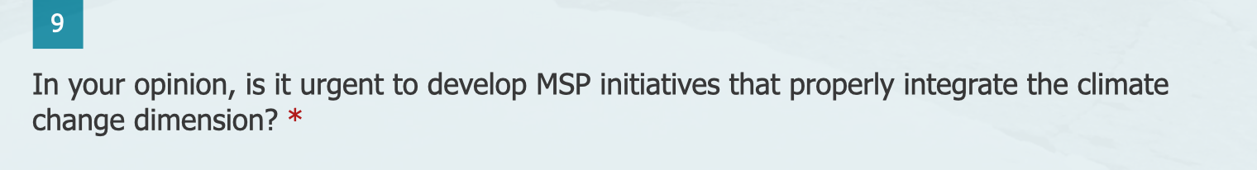

Not urgent at all Go to 10.1
Little urgency Go to 10.1
Moderate urgency Go to 10.2 (a to d)
High urgency Go to 10.2 (a to d)
Not sure/Do not know Go to 10.1

10.1

 | 1 | 2 | 3 | 4 | 5
Not at all |  |  |  |  |  | Very much

10.2 - a

 | 1 | 2 | 3 | 4 | 5
Not at all |  |  |  |  |  | Very much

10.2 - b

 | 1 | 2 | 3 | 4 | 5
Not at all |  |  |  |  |  | Very much

10.2 - c

10.2 - d

 | 1 | 2 | 3 | 4 | 5
Not at all |  |  |  |  |  | Very much

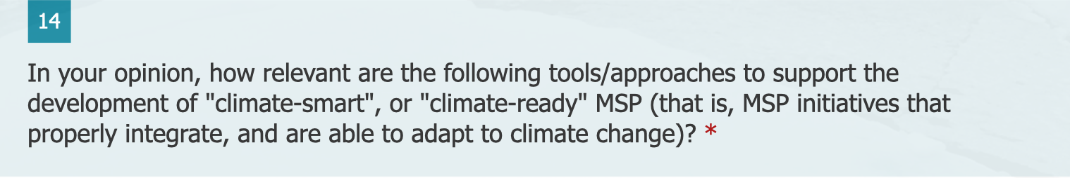

 | 1 (Not important at all) | 2 | 3 | 4 | 5 (Very important) | Not sure/Do not know
Climate modelling and mapping tools
Climate vulnerability and risk analyses
Visioning and scenario planning
Dynamic ocean management (management that rapidly changes in space/time in response to changes in the ocean and its users)
Anticipatory zoning (implementation of governance regimes based on observed environmental trends and anticipated future human needs)
Adaptive management and governance

Yes Go to 16.1
Not sure Go to 16.2
No Go to 17

16.1

16.2

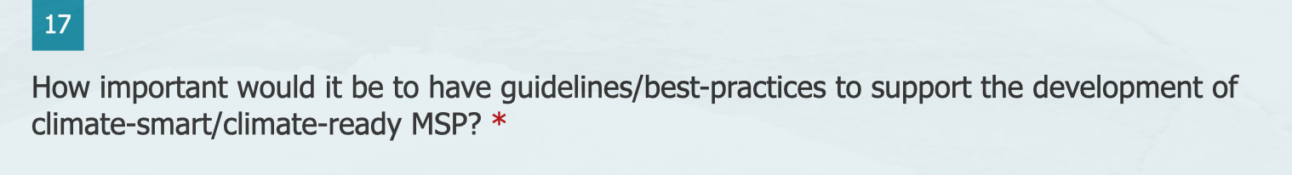

 | 1 | 2 | 3 | 4 | 5
Not at all |  |  |  |  |  | Very much

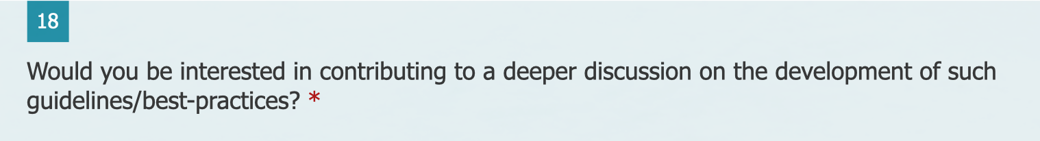

Yes Go to 19
Not sure Go to 19
No Go to 20

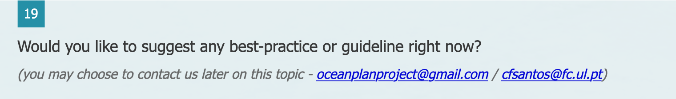

Yes Go to 21
Not sure Go to 21
No Go to 23

Marine spatial plan
MSP pilot project
MSP research project

Marine legislation
MSP strategy
Not sure/Do not know

Other: ______________________________________________________

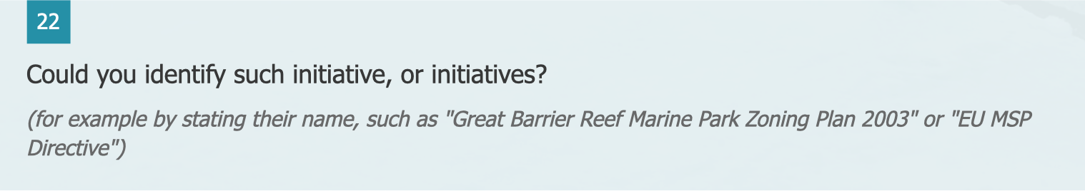

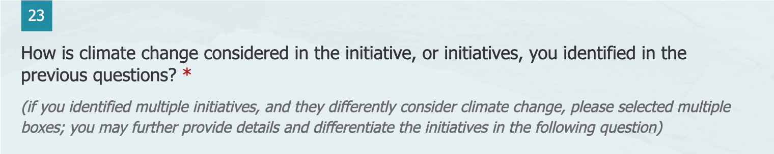

Mentioned as a challenge
Mentioned as a knowledge need
Mentioned as a driver for adaptive MSP

Included in the objectives of the plan/pilot project/strategy/legislation
Specific management actions to address climate change are identified in the plan/pilot project/strategy/legislation
It is the central topic of the MSP research project/tool
It is addressed as part of the MSP research project
Not sure

Other: ______________________________________________________

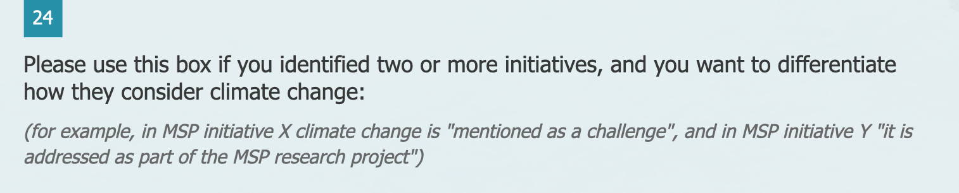

Yes Go to 26
Not sure Go to 26
No Go to 27

By anticipating or avoiding climate-induced conflicts among ocean uses
By identifying and protecting areas for climate refugia
By decreasing other local human pressures on marine ecosystems and thus increasing their resilience

By increasing ocean literacy and thus reducing social/cultural vulnerability
By prioritising areas to the development of renewable energy
By identifying areas for blue carbon capture and storage
By prioritising allocation of space to ocean uses that choose eco-efficient technologies and power sources that tend to zero emissions
By providing an integrated, cross-sectoral approaches to manage ocean use
Not sure/Do not know

Other: ______________________________________________________

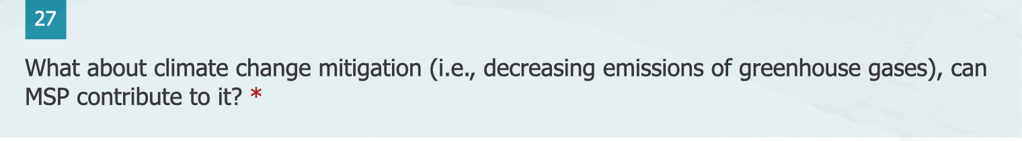

 | 1 | 2 | 3 | 4 | 5
Not at all |  |  |  |  |  | Very much

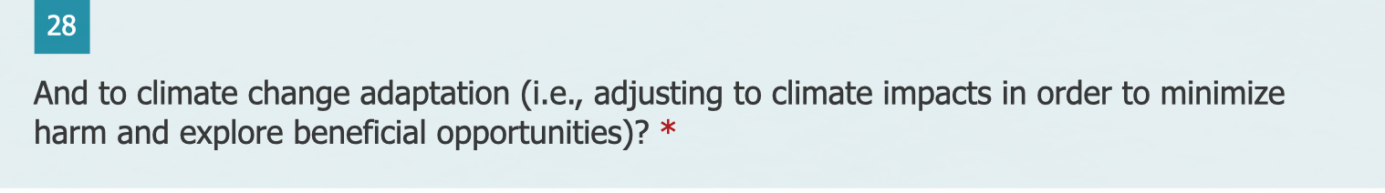

 | 1 | 2 | 3 | 4 | 5
Not at all |  |  |  |  |  | Very much

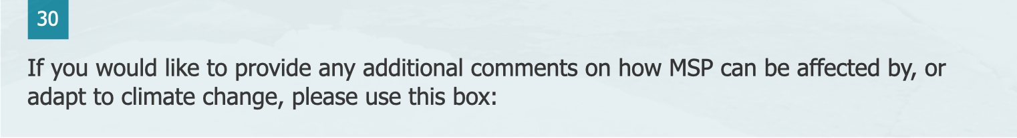

Less than 1 year
Up to 5 years
From 5 to 10 years

From 10 to 20 years
More than 20 years
Prefer not to say

Natural sciences
Social sciences
Prefer not to say

Other: ______________________________________________________

Doctoral degree
Master degree
Bachelor degree
Prefer not to say

Other: ______________________________________________________

Academia/Research Institution
Government/Governmental Agency
Local Authority (municipality, province)
Non-Governmental Organization (NGO)
Marine Industry
Private Consultancy Firm
Prefer not to say

Other: ______________________________________________________

Under 20
20 to 29
30 to 39
40 to 49
50 to 59
Over 60
Prefer not to say

Female
Male
Other
Prefer not to say

